Robin Mehta (robimeht)

AI Homework 5

**Exercise 1**

**1. n persons in a room, and 365 days in a year.**

a) What is the probability that at least two persons have the same birthday?

**365! / ((365-n)! * (365^n))**

b) Calculate this probability for n=50.

P(nobody shares birthday) = = 0.0296

1 – P(nobody shares birthday) = **0.9704**

c) **n = 23** for probability to be greater than 0.5

Tried n=25:  Then, n=20:  Then, **n=23:**

**2. 100 total hard drives, 20 defective. Quality control selects 2 hard drives to test without replacement.**

a) 20/100 = 0.2

b) 19/99 = 0.1919

c) 1/5 * 19/99 = 0.03838

**3. Fill in table: P(A,B) = P(A,B,c) + P(A,B,~c)**

|  |  |  |  |  |
| --- | --- | --- | --- | --- |
| A | B | P(A, B, c) | P(A, B, ~c) | P(A, B) |
| T | T | 0.25 | 0.15 | 0.4 |
| T | F | 0.05 | 0.1 | 0.15 |
| F | T | 0.05 | 0.2 | 0.25 |
| F | F | 0.1 | 0.1 | 0.2 |

P(A) = P(A,b) + P(A,~b) = 0.4 + 0.15 = 0.55

**4. SFOT problem**

A = Predict SFOT

B = Actual SFOT

P(b|a) = ?

P(b) = 6/365

P(a|b) = 0.95

P(a|~b) = 0.15

P(b|a) = [P(a|b)*P(b)] / P(a)

P(a) = P(a,b) + P(a,~b)

= [P(a|b) * P(b)] + [P(a|~b) * P(~b)]

= [0.95*(6/365)] + [0.15*(359/365)]

= 0.01561643835 + 0.14753424657

= **0.16315068492**

**Exercise 2**

**1. P(w,s,~r,c) = P(w|s,~r) * P(~r|c) * P(s|c) * P(c)**

= .7 * .1 * .2 * .8 = **0.0112**

**2. Handwritten**

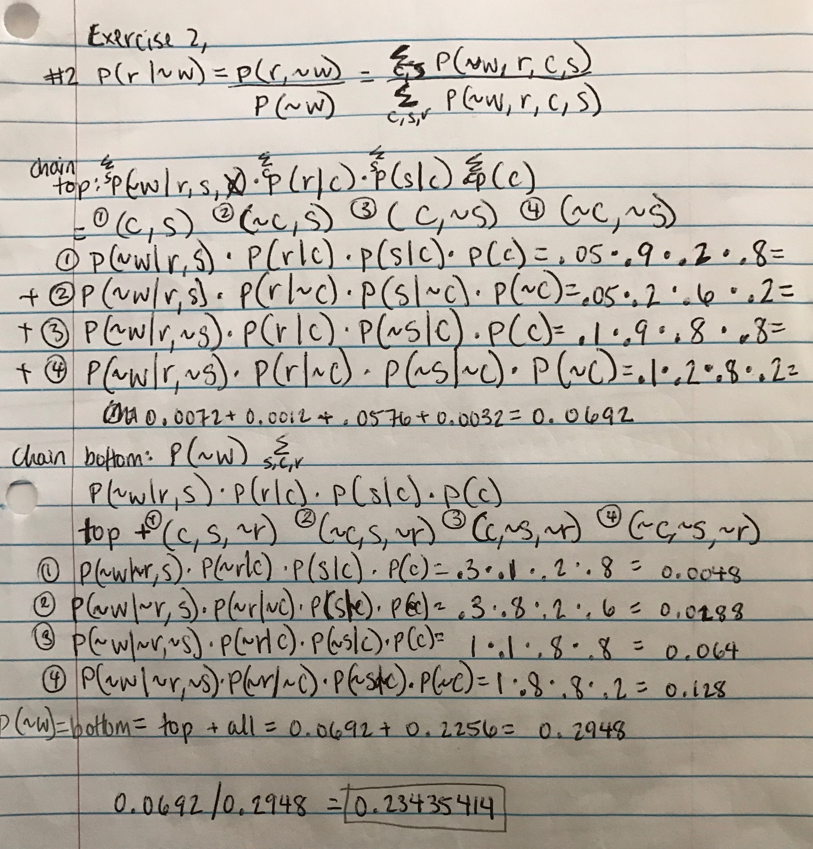

**3. Handwritten**

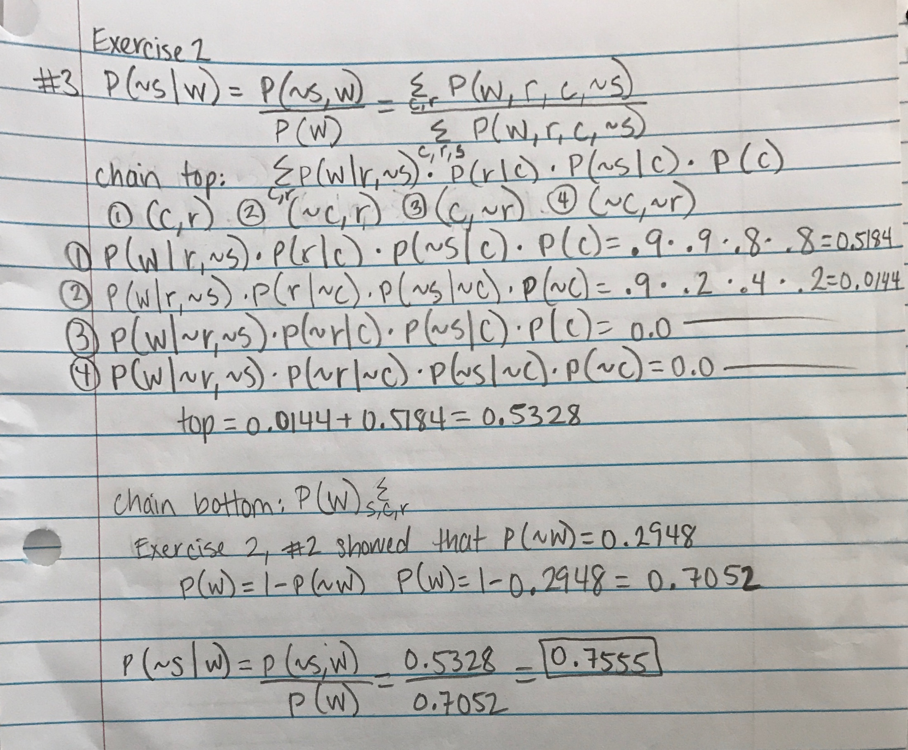

**4. Handwritten**

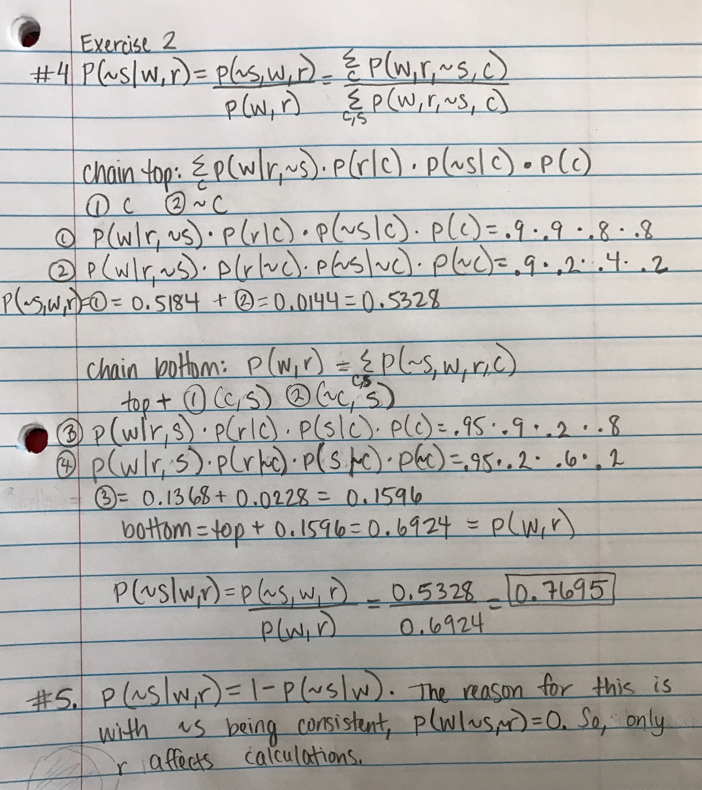

**Exercise 3**

**1. What quantity does a represent?**

α **= 1/P(b)**

**2. Write the factorized expression for P(J|b) after eliminating M.**

α Σ(a,e,m) P(J|a) P(m|a) P(a|B,e) P(B) P(e)

= α Σ(a)P(J|a) Σ(e) P(a|B,e) P(e)

= α P(b)Σ(e)P(e)P(a|b,e)P(J|a)

We can leave out Σ(m) P(m|a) because **m** is conditionally independent of J|a, and results in 1.

**3. Write the condition probability table for variable A after eliminating variable E. (Work handwritten below.)**

|  |  |
| --- | --- |
| B | P(A) |
| T | 0.94002 |
| F | 0.001578 |

**4. Write the conditional probability table for J after eliminating A. (Work handwritten below.)**

|  |  |
| --- | --- |
| B | P(J) |
| T | 0.849017 |
| F | 0.0513413 |

**5. Eliminate variable B and write the probability table for J. What do these probabilities represent? (Work handwritten below.)**

This represents the marginal probability of J:

|  |
| --- |
| P(J) |
| 0.05213898 |

Work:

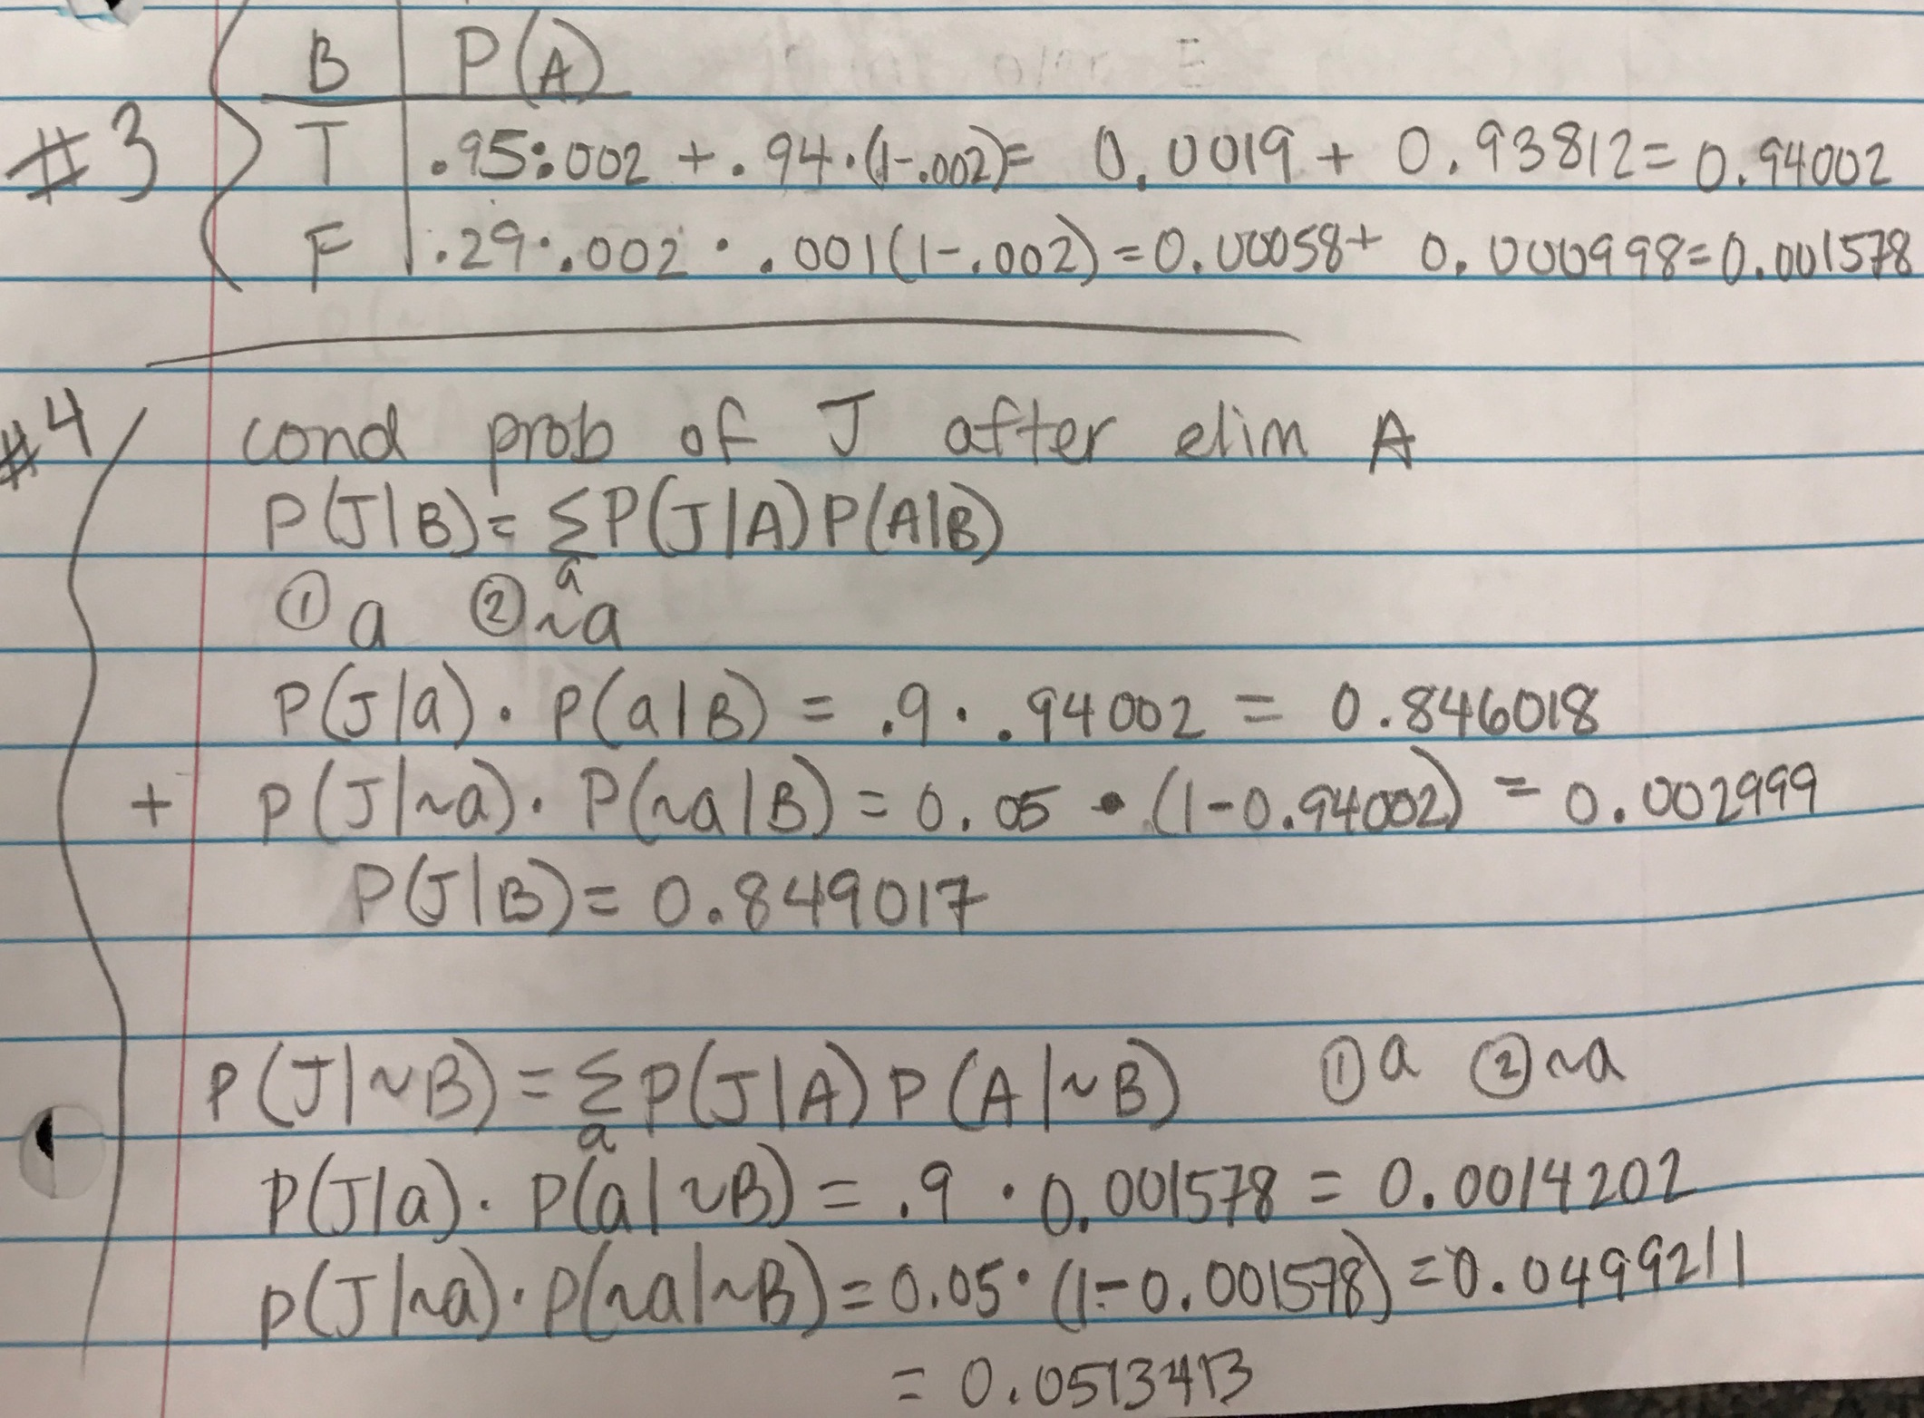

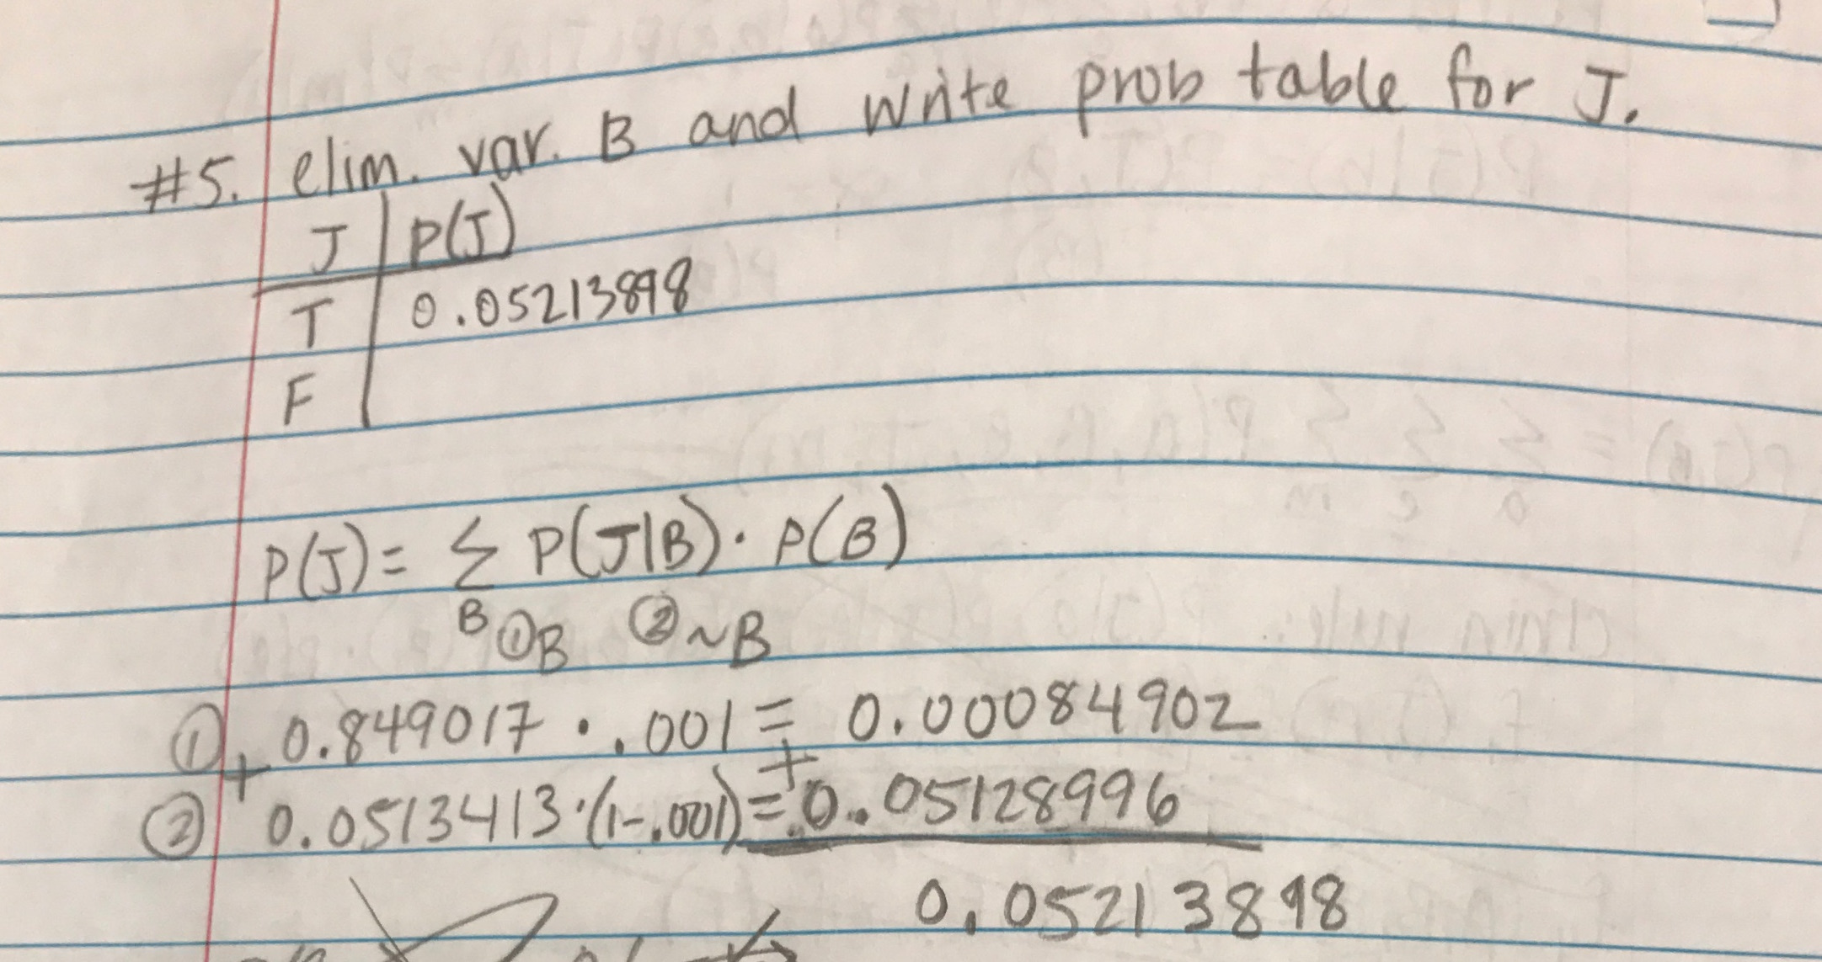

**Exercise 4**

**1. Draw Bayesian network (Handwritten)**

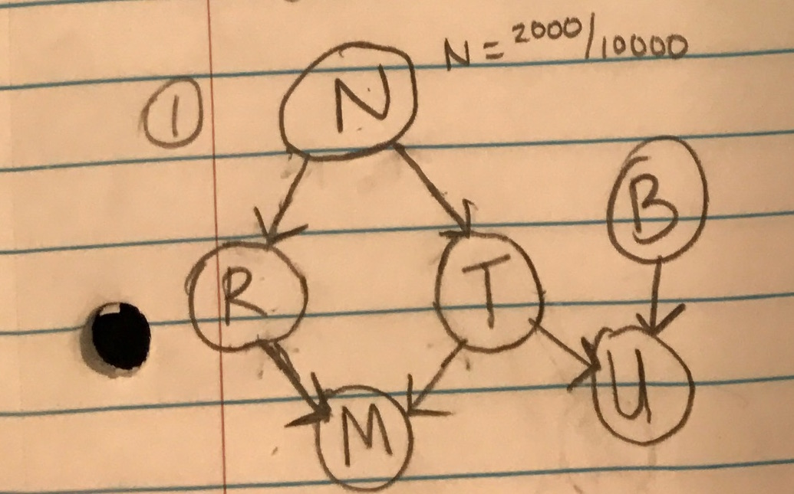

**2. Factorized expression for full joint distribution, P(N, R, T, M, U, B):**

P(N) * P(R|N) * P(T|N) * P(M|R,T) * P(U,T,B) * P(B)

**3. Conditional probability table for each node:**

Marginal Probability of N:

|  |  |
| --- | --- |
| N | P(N) |
| T | .2 |
| F | .8 |

Conditional:

|  |  |
| --- | --- |
| N | P(R) |
| T | .9 |
| F | .3 |

Conditional:

|  |  |
| --- | --- |
| N | P(T) |
| T | .6 |
| F | .4 |

Conditional:

|  |  |  |
| --- | --- | --- |
| R | T | P(M) |
| T | T | .168 |
| T | F | .042 |
| F | T | .08 |
| F | F | .042 |

Conditional:

|  |  |  |
| --- | --- | --- |
| B | T | P(U) |
| T | T | .5 |
| T | F | .05 |
| F | T | .3 |
| F | F | .01 |

Marginal Probability of B:

|  |  |
| --- | --- |
| B | P(B) |
| T | .05 |
| F | .95 |

**4. Calculate marginal probabilities for each node.**

P(N) = .2

P(R) = .42

P(T) = .44

P(M) = .0749824

P(U) = .14312

P(B) = .05

Handwritten work:

